Here we create several new wallet accounts to be able to use the "ballot contract".
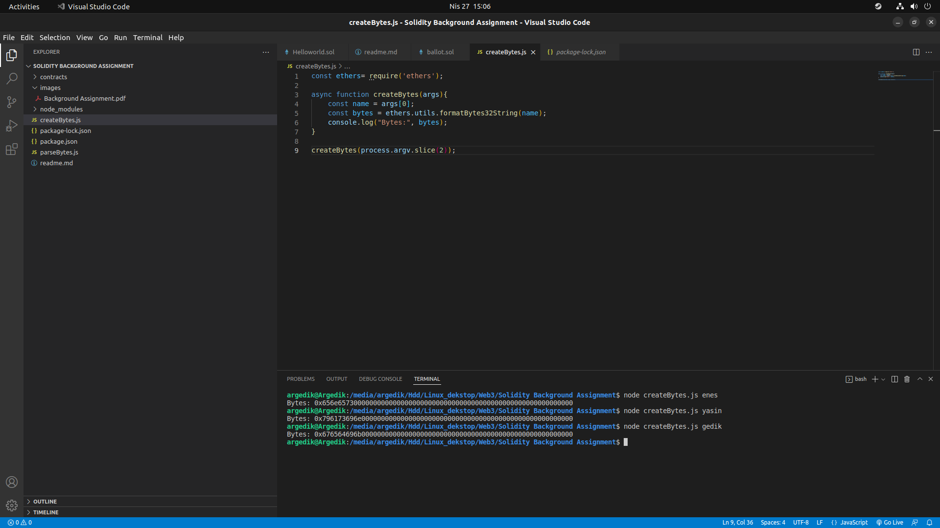
After compiling our "ballot.sol" file, we enter the addresses we created in the "Deploy" section as a list.
Example;
["0x656e657300000000000000000000000000000000000000000000000000000000", "0x796173696e000000000000000000000000000000000000000000000000000000", "0x676564696b000000000000000000000000000000000000000000000000000000"]
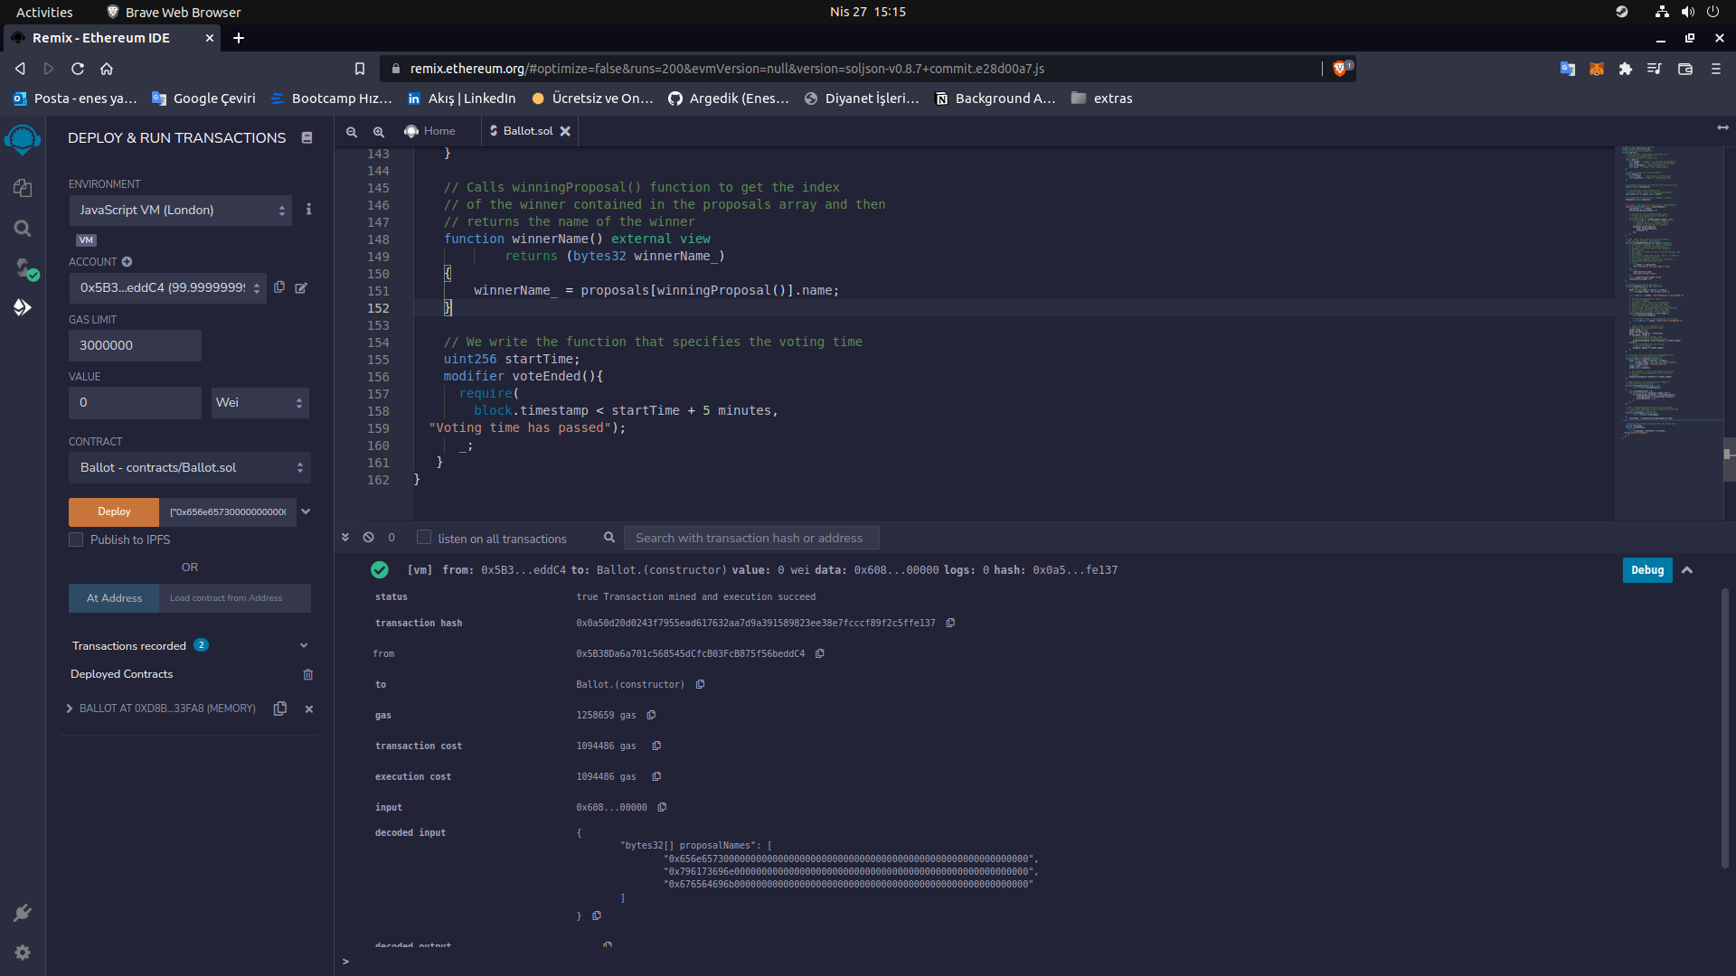
1

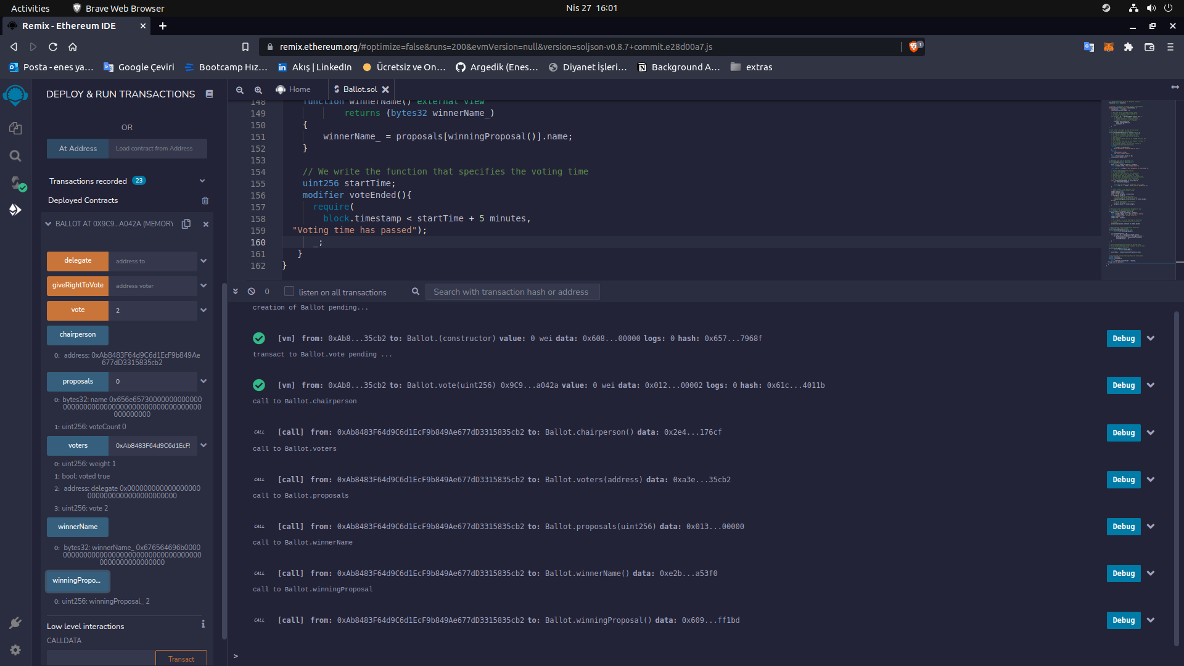
We distributed our contract and cast our vote :)

